Kubernetes Basics
– Kubernetes cluster orchestration system

The goals :
- Deploy a containerized application on a cluster.
- Scale the deployment.
- Update the containerized application with a new software version.
- Debug the containerized application.
1. Create a Kubernetes cluster
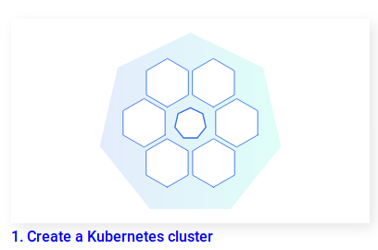

(ref: https://kubernetes.io/docs/tutorials/kubernetes-basics/create-cluster/cluster-intro/)

– Kubernetes coordinates a highly available cluster of computers that are connected to work as a single unit.

– To make use of this new model of deployment, applications need to be packaged in a way that decouples them from individual hosts: they need to be containerized.

Cluster diagram :

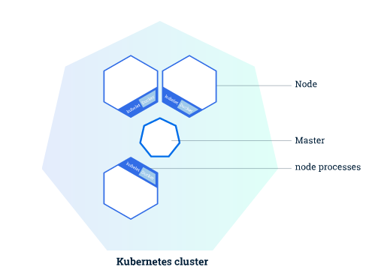

– The components
Master : The Master is responsible for managing the cluster. The master coordinates all activities in the cluster.
Node : A node is a VM or a physical computer that serves as a worker machine in a Kubernetes cluster. Each node has a Kubelet( an agent for managing the node and communicating with the Kubernetes master . The node also have the tools for handling operations ( Such as : Docker or rkt )

A short presentation of “rkt” :
ref: https://blog.wescale.fr/2017/01/23/introduction-a-rkt/

2. Kubernetes Deployment

– Once we have a running Kubernetes cluster, we can deploy the containerized applications on top of it. BY creating a Kubernetes Deployment configuration.
– Deployment instructs Kubernetes (by master)how to create and update instances of your application.
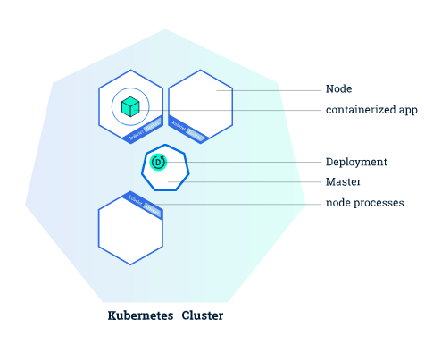

3. Viewing Pods and Nodes
* Pod
– Pods are the atomic unit on the Kubernetes platform. When we create a Deployment on Kubernetes, that Deployment creates Pods with containers inside them

Each Pod is tied to the Node where it is scheduled, and remains there until termination or deletion :

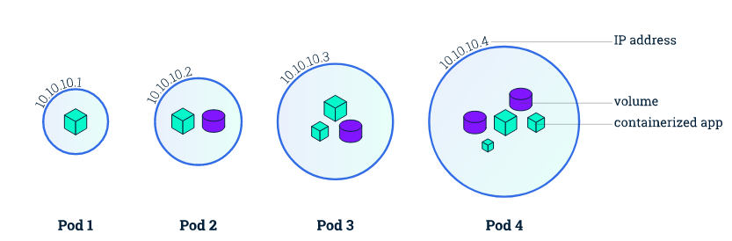
* Node
– A pod runs always on a Node
– A node can have multiple pods
– Each node is managed by the Master
Master's automatic scheduling takes into account the available resources on each Node.

Every Kubernetes Node runs at least a Kubelet ( a process responsible for communication between the Kubernetes Master and the Node; it manages the Pods and the containers running on a machine. )
The commands common of Kubelet :
- kubectl get - list resources
- kubectl describe - show detailed information about a resource
- kubectl logs - print the logs from a container in a pod
- kubectl exec - execute a command on a container in a pod

Node Overview :
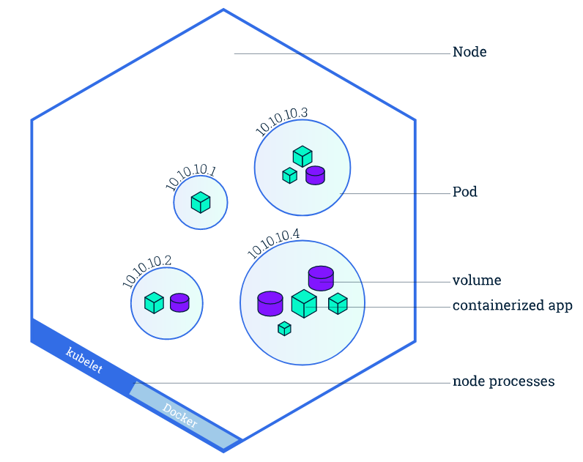

4. Using a service to expose the APP

– Kubernetes Services
It defines a logical set of Pods and a policy by which to access them.
A Service is defined using YAML (preferred) or JSON, like all Kubernetes objects.
(Although each Pod has a unique IP address, those IPs are not exposed outside the cluster without a Service. )
In a Services configuration :
- ClusterIP (default) - Exposes the Service on an internal IP in the cluster. This type makes the Service only reachable from within the cluster.
- NodePort - Exposes the Service on the same port of each selected Node in the cluster using NAT. Makes a Service accessible from outside the cluster using <NodeIP>:<NodePort>. Superset of ClusterIP.
- LoadBalancer - Creates an external load balancer in the current cloud (if supported) and assigns a fixed, external IP to the Service. Superset of NodePort.
- ExternalName - Exposes the Service using an arbitrary name (specified by externalName in the spec) by returning a CNAME record with the name. No proxy is used. This type requires v1.7 or higher of kube-dns
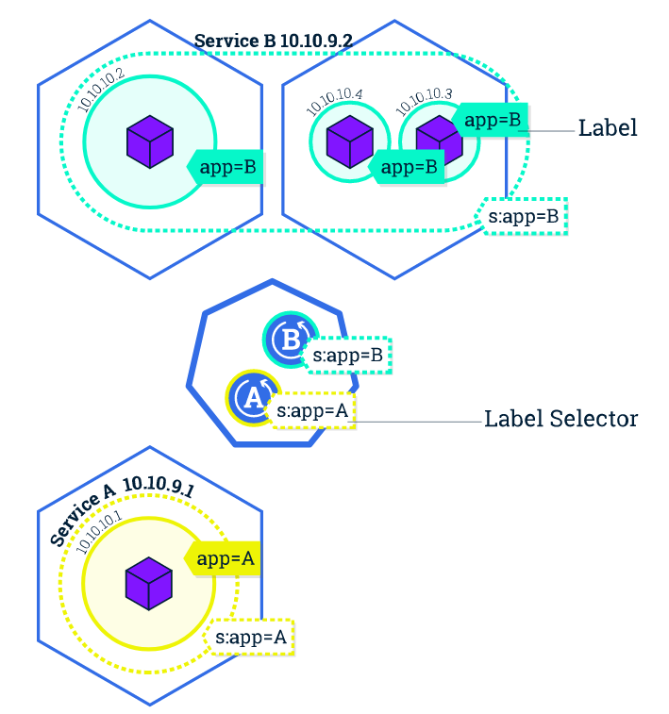
Labels can be attached to objects at creation time or later on. They can be modified at any time. Let's expose our application now using a Service and apply some labels.

5. Running Multiple Instances of the APP
– We can scale an app using kubectl
Background : The Deployment created only one Pod for running our application. When traffic increases, we will need to scale the application to keep up with user demand.
Scaling is accomplished by changing the number of replicas in a Deployment




